Signed Right Shift Operator (>>)
The signed right shift operator shifts a bit pattern of a number towards the right with a specified number of positions and fills 0. The operator is denoted by the symbol >>. It also preserves the leftmost bit (sign bit). If 0 is presented at the leftmost bit, it means the number is positive. If 1 is presented at the leftmost bit, it means the number is negative.
In general, if we write a>>n, it means to shift the bits of a number toward the right with a specified position (n). In the terms of mathematics, we can represent the signed right shift operator as follows:
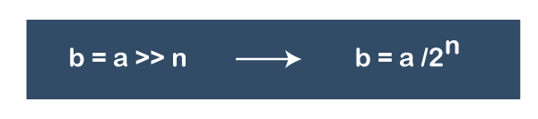

Note: When we apply right shift operator on a positive number, we get the positive number in the result also. Similarly, when we apply right shift operator on a negative number, we get the negative number in the result also.
Example: Apply the signed right shift operator with specified positions 4 if x = 256 and x = -256.
If x = 256
256 >> 4
256/2⁴ = 16
If x = -256
-256 >> 4
-256/2⁴ = -16
In the above example, we have observed that after shifting the operator 256 converted into 16 and -256 converted into -16.

